
Canterbury Road Primary School
“a friendly, happy place to learn”

Curriculum Statement, reviewed June 2022

Intent
At Canterbury Road, we plan our curriculum to fulfil the requirements of the National Curriculum and EYFS curriculum, to meet the needs of our pupils and to support our ethos of ‘a friendly, happy place to learn’.
Staff and Governors have worked together to determine what our aims for our pupils are – not just academically but socially and morally too and what sort of experiences and opportunities we want for them whilst they are at Canterbury Road and into their future. Our curriculum is beyond learning facts and skills although these are paramount, it is designed to develop positive attitudes and morals, encourage children to be inquisitive and aspirational and teach them to be resilient and independent.
We identified that our curriculum should teach the children the essential skills and knowledge in each subject and phase but also that it should support our pupils to become -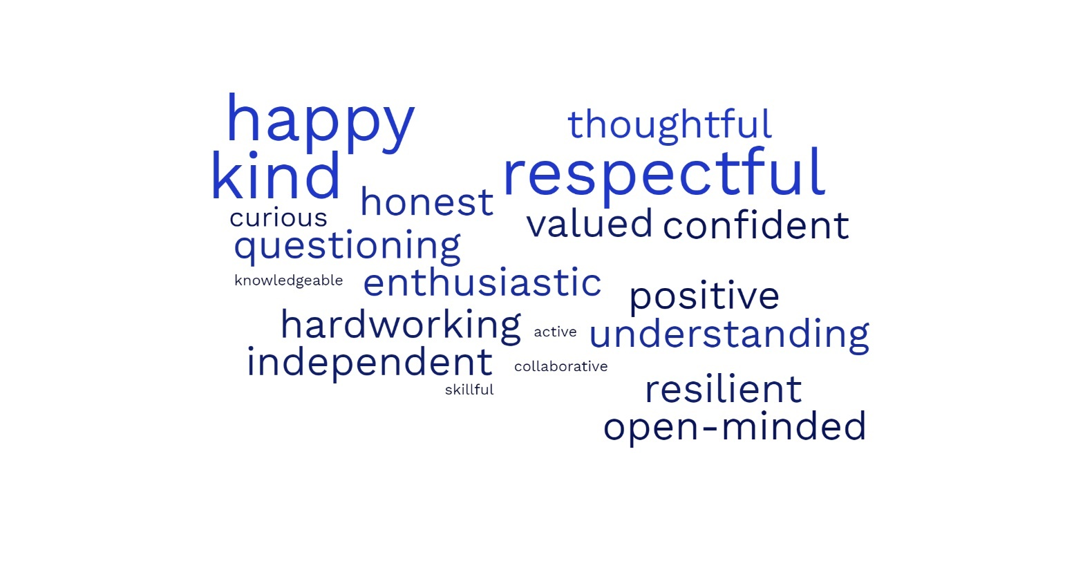
This intent wraps around the curriculum and each lesson.

Implementation
EYFS

KS1 and KS2
The National Curriculum (NC) is followed in all subjects and teach the Kent syllabus for RE. Each subject has been split into schemes of work for the year groups and these usually last a term. In some subjects, particular topics or knowledge and skills has to be taught in specific year groups but otherwise the subject leaders have designed their curriculum to meet the needs and interests of pupils and NC. Each scheme of work is based on 6 lessons per term and teachers will adjust them if terms are longer or shorter.
The curriculum has a mixture of school-developed units and purchased schemes which staff adapt to meet need.
Most subjects are taught weekly although some are taught in alternate terms (typically Geography/History and Art/DT). Sometimes lessons are grouped together in a week, for example a cooking unit where it is necessary to have lessons following each other in quick succession.
All staff are committed to getting the best from our pupil and are –
role models, encouraging, reassuring, challenging, empathetic, creative,
and have -
high expectations, excellent curricular skills and knowledge and a commitment to each child and family
and are skilled and knowledgeable about -
how to ensure each child does their best in all aspects of school life.

Currently, each subject leader is reviewing their subject/s. They are ensuring that there is a progression of knowledge, skills and vocabulary across each year group and that learning is sequenced appropriately. Later this year, we hope to look at building specific opportunities for retrieval into their schemes and how to further enhance opportunities to develop language and assessment too.

Impact
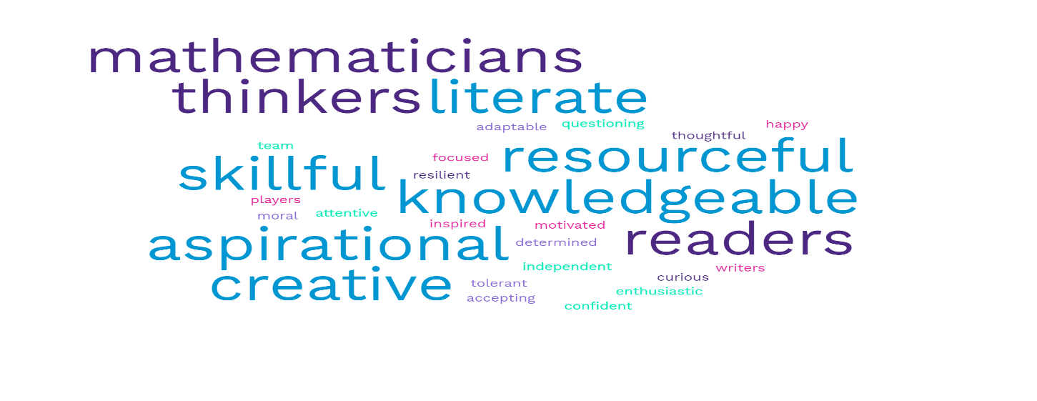
As a result of our effective curriculum, our children will be –
Canterbury Road pupils -
- will be knowledgeable and skilful
- will make good decisions
- think and care deeply
- attain and achieve their best
- be respectful
- be proud of who they are and what they have achieved
- know about the world
- be good citizens.

